Lesson 5 Demo 10: Inspect a Service on Swarm

This section will guide you to:

* Inspect a service on the Docker swarm

**Step 1:** Start a replicated service using the **redis**image

*sudo docker service create --replicas 3 --name redis redis:3.0.6*

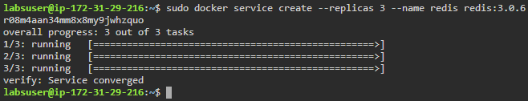

**Step 2:** Check the service tasks assigned to different nodes by the swarm manager

*sudo docker service ps redis*

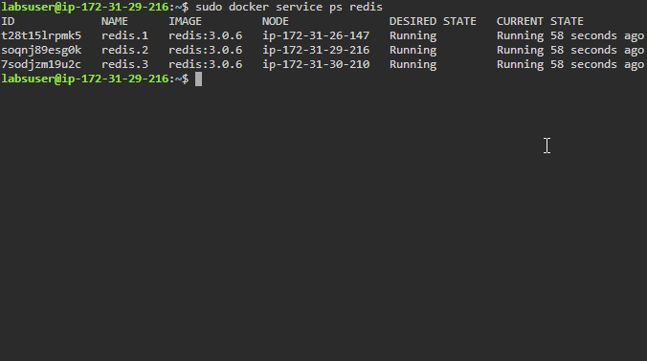

**Step 3:** Inspect the *redis* service in an easily readable format

*sudo docker service inspect --pretty redis*

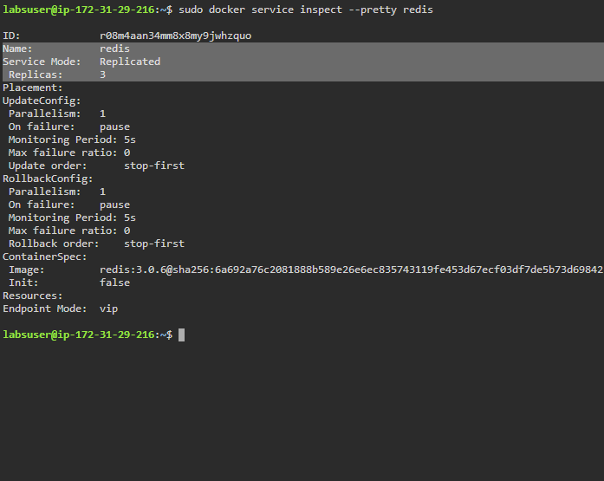

**Step 4:** Use the following command to return the service details in JSON format

*sudo docker service inspect redis*

